# Runaway Train

## High Concept:

A train in the old west, laden with gold, that is heading through outlaw territory. **Stopping is not an option**. The train carts are piled high with riches, the word is out, and every outlaw is gunning for the loot.

## Summary:

Speed through open deserts, jumping tracks to avoid obstacles, dealing with marauders and try to make it to the goal with as much of the gold as possible.

This is no ordinary train, and you are no ordinary train driver! The train is specially equipped and can tilt or jump on command to avoid obstacles. As the steel-hearted driver you can also throw wrenches or at any marauders that get too close. Collect more gold pieces as you go and do anything you can do to keep your total up!

## Genre/comparisons:

The immediate comparison is with other “infinite runner” games like **Temple Run**. The difference here being that the user has more control over their route and there are lulls in the action.

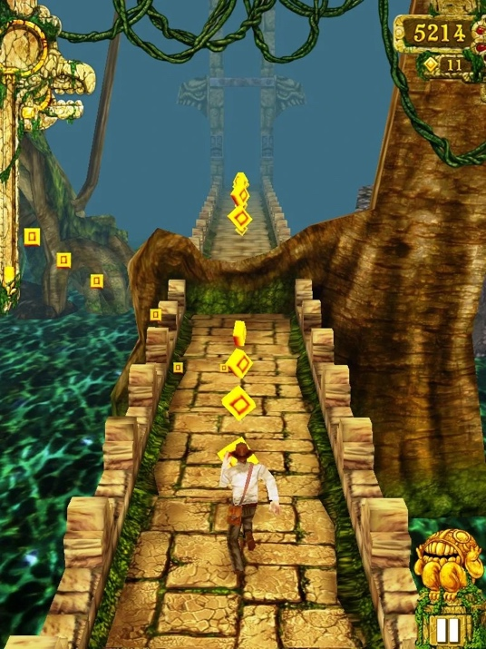

Temple Run

Another comparison, particularly in the controls and UI would be the train driving sections of the Nintendo DS game **Spirit Tracks**.

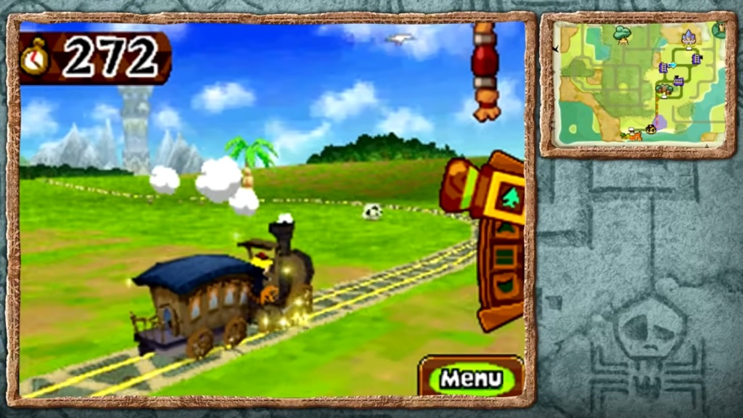

Spirit Tracks

There is also a customization element. At certain checkpoints the player is able to upgrade their train. This is similar to the retro game **Overlander** in which players were able to purchase weapon and armour upgrades for their car before heading back on the road.

Overlander

## Unique Selling Points (USPs)/features:

It’s an infinite runner that adds greater levels of choice and customisation and is more goal driven. The complexity and scope of the game is easily increased and decreased.

## Description of Game:

Once the player starts a stage, the train is always moving. There is an indicator on the screen that shows how far you have until the next way station. As you progress you can tilt the train to collect gold pieces and hurl projectiles to scare off bandits. There will be certain obstacles on the track that you may have to take action to avoid by jumping to switch tracks or tilting to one side or the other. You can also use your projectiles to activate switches that will change the route your train can take. Some routes may offer greater rewards but with that comes greater threats!

After you lose a certain threshold of money you have a set period in which to replenish it. If you fail the empty carriage gets jettisoned and your max total decreases. Your train will also become faster as a result.

After a while you will enter certain way-stations where the local sheriff has things under control, allowing you to stop your train and trade for essential supplies. Fix the damage to your train, purchases new carriages and other upgrades. All will result in trading more gold though, reducing your final total.

The game ends once all stages have been completed and the train has completed its journey. The aim of the game is to achieve the highest gold stash you can.

## Control Scheme

### Mouse

Use the mouse to aim your projectiles. Movement controls a crosshair on the screen and the **Left Mouse Button** launches a projectile. Also used to navigate game menus.

### Keyboard

#### Arrow Keys

Use the **Arrow Keys** to tilt the train left and right and to aim the direction of your jump. Also can be used to navigate game menus.

#### Space

In certain situations, pressing **Space** will allow you to switch tracks or jump.

Other keys might be necessary to active different weapon upgrades or to allow the user to elect their current projectile.